Exp. 11. Calculate the Potential of a pH SENSOR using NanoHub
Aim: To obtain the Potential of a sensor by varying the pH value of an electrolyte and insulator thickness Software: NanoHub Online Tube
Output:(1)
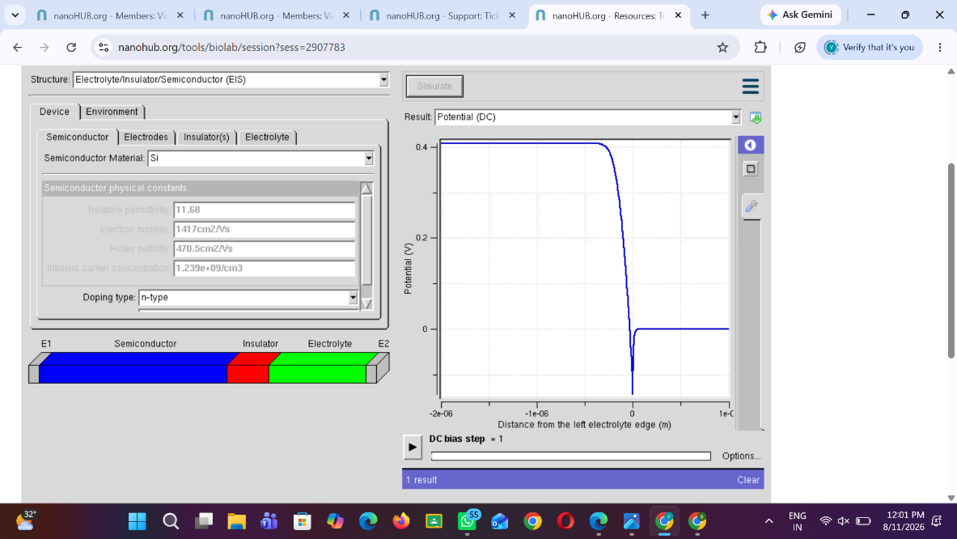
(2)
